Session 6: A Country in a Box Showcase

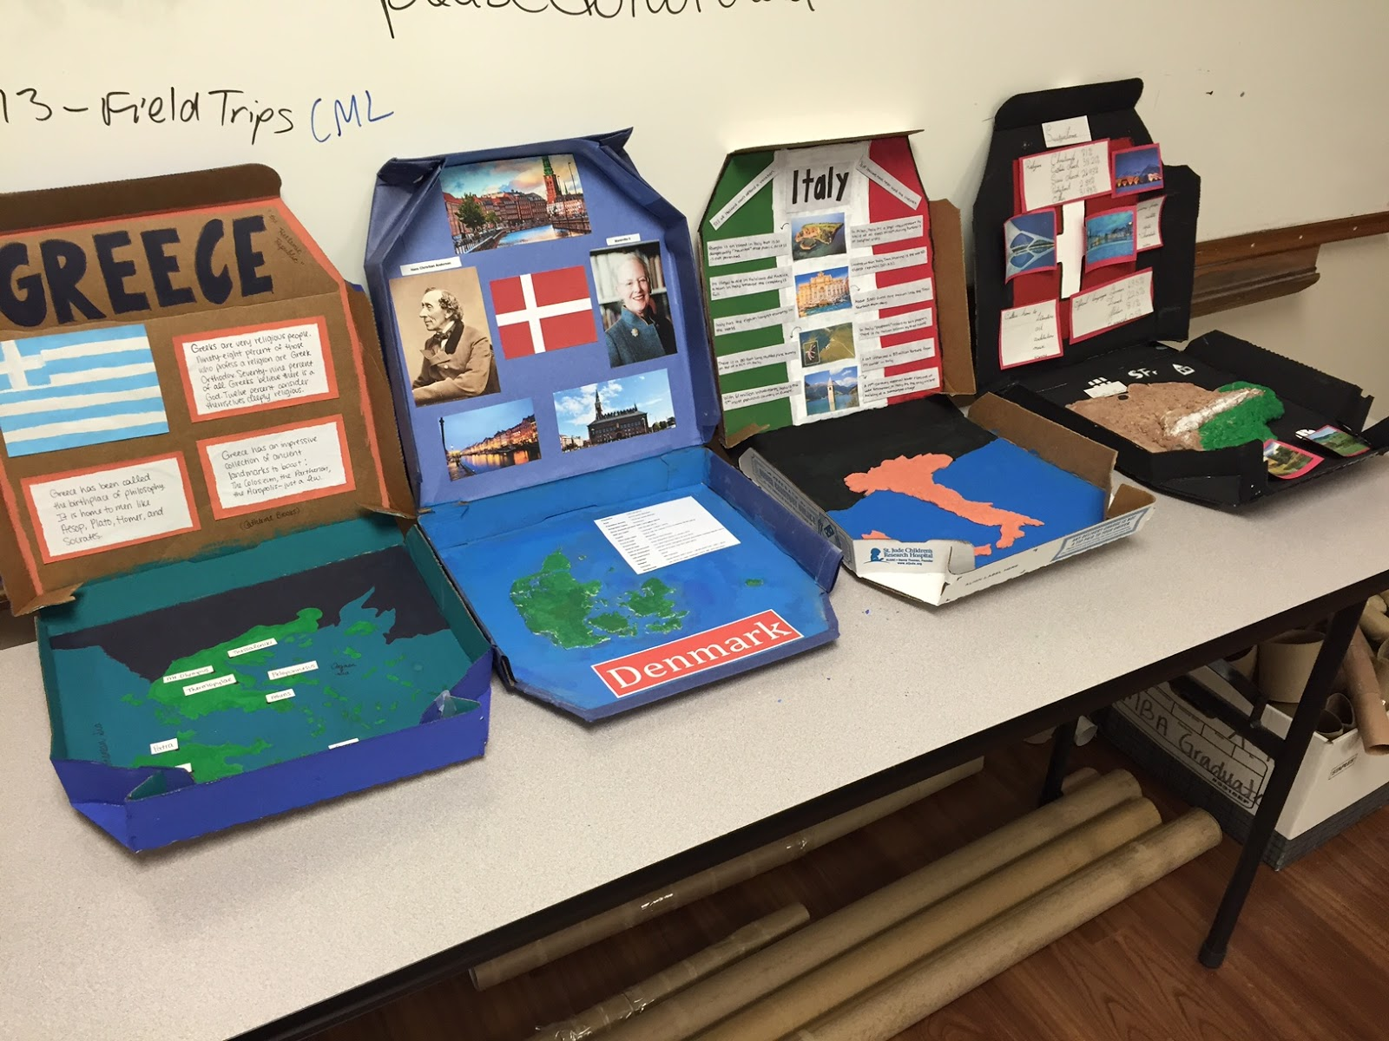
Task: to produce a box that reflects and informs others about your chosen country. How creative can you be?

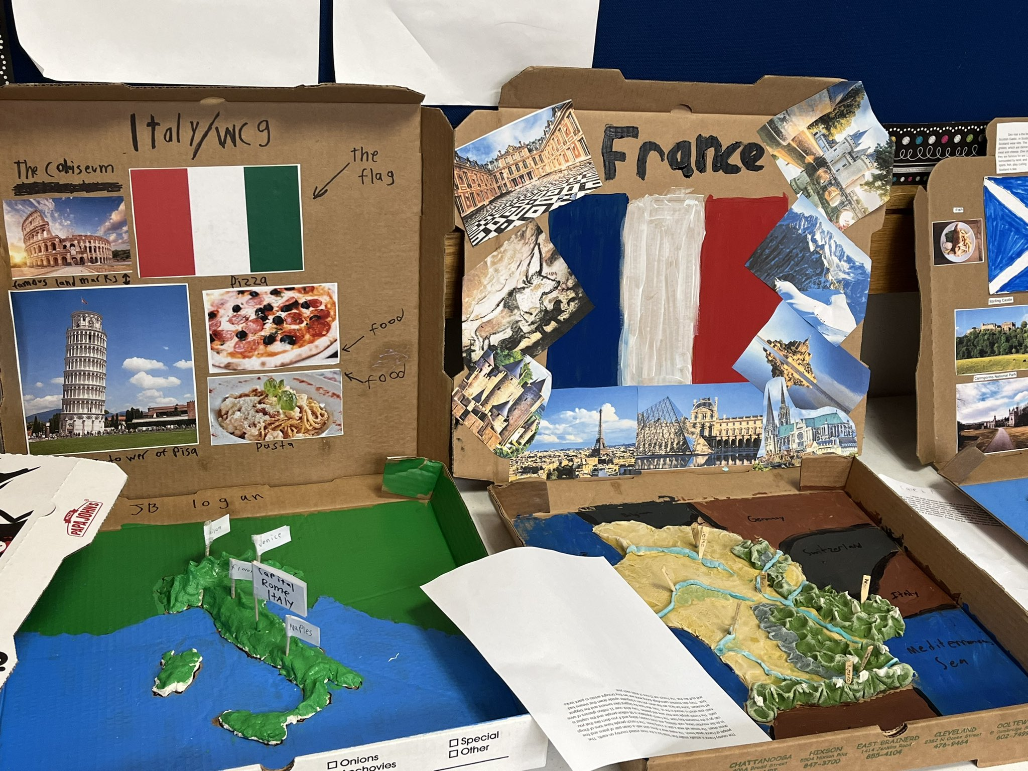
Your task is to research the (European) country you have been allocated. It is your responsibility to organise with your group, who is responsible for researching different aspects of their culture and traditions.

<Insert date> your final piece of work will be presented will be judged based on creativity, collaboration and information being displayed.

You may wish to research and include information about:
- the language or languages spoken
- population
- key facts about the country
- cuisine
- traditions
- traditional clothing
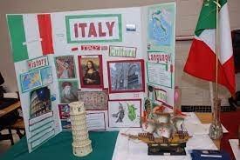
- music
- sport
- history

