Teacher Notes Session 2: Why learning languages is important.

Lesson Objective:
To understand a range of reasons why learning a language is important.
To discover why other people have chosen to learn another language.

Resources:
PowerPoint Slides – Session 2 - Why learning languages is important - MFL Transition Project

Recall / Review
Recap on the work done in Session 1 around why language learning is important.
- increase job opportunities
- understand other cultures and ways of life
- research says that learning a language can improve memory
- develop confidence
- improve communication skills
- get more enjoyment from holidays abroad

Activity One - Think / Pair / Share
(suggested time for activity – 5 minutes)
Introduce the statement in Slide 2: “I like to learn new languages so I can understand other people.”
Step One (suggested time 1 minute) – students are reflecting on the sentence (no writing or speaking),
Step Two (suggested 2 minutes) – students share their reflections with their partner.
Step Three (suggested 2 minutes) – students now have the opportunity to share their reflections with the rest of the class, with an emphasis on explaining what their partner said (to ensure good listening).

Activity Two - But why? Mindmap
(suggested time for activity – 15 minutes)
Introduce slide 3. Ask pupils what language this might be (using the image as a clue).

Note - each slide with a different language is the same sentence: I like to learn new languages so I can understand other people.

Note - the information for each language is for teacher knowledge rather than for pupils but there are interesting facts you may wish to share.

This is the Elvish language created by J.R. R. Tolkein for the Lord of the Rings etc.
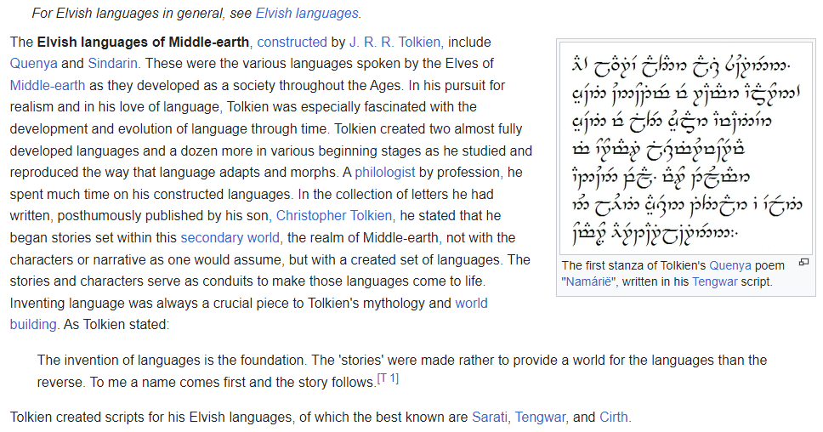
Slide 4: Repeat as above.
This is Klingon from Star Trek
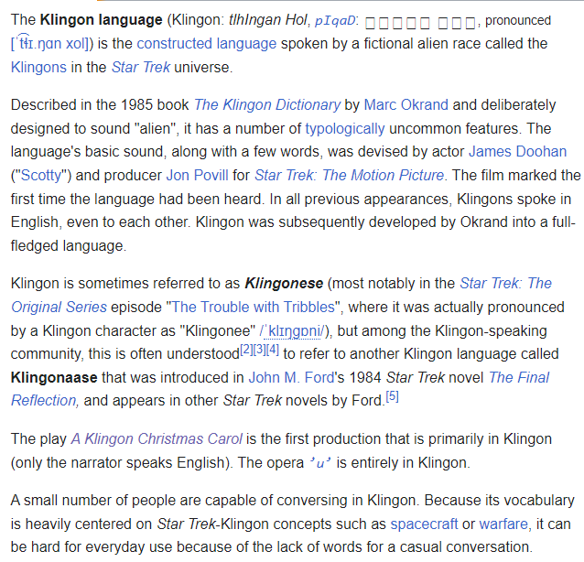

Slide 5: This is Minion from the Despicable Me films

Slide 6: This is the Na’vi language from the Avatar films.
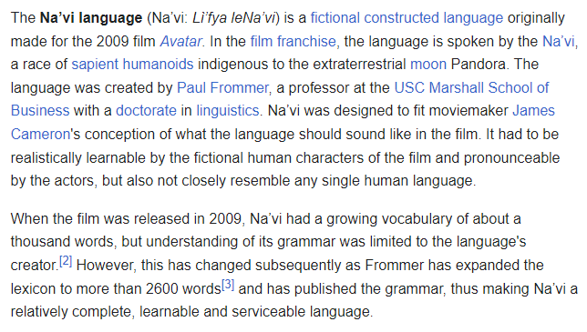

Slide 7: This is the Atlantean language from the Disney animation film ‘Atlantis: The Lost Empire’.

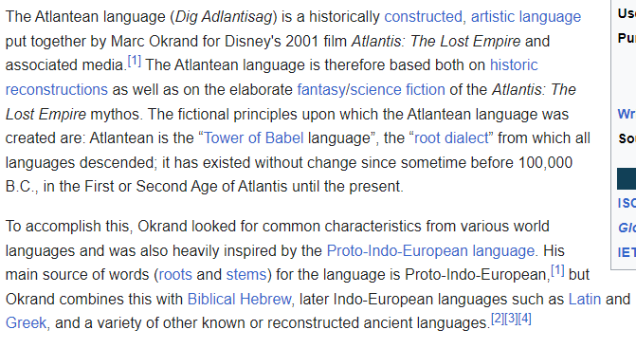

Ask pupils why they think these languages were created – use optional Mind Map worksheet.
Students to share their ideas with the class.
Ideas to support discussion in this task:
- languages are part of the history and culture of a place / group of people
- languages reflect a society
- Having a common language joins people together
- Making an effort to learn a particular language links one person to a larger community

Activity 3 – Who / What / Why?
(suggested time for full activity – 10-15 minutes)
Use the celebrity link in the slide (from European Day of Languages) to identify:
- Who the person is
- What job they do
- Why they speak another / several languages
Use the note taking sheet (optional – this can also be done verbally using the headings in the sheet as a prompt).

Activity 4 – Which languages and why?
Slide 9: Use the Zlatan Ibrahimovic interview link. Students to listen and list the languages he is speaking.
(Background information, he speaks Swedish and Serbo-Croation (Bosnian) as his mother tongues and is fluent in English and Italian. Here is speaking in Spanish and French also).
Explore with students why he makes the effort to learn other languages.
Slide 10: use Gelson Fernandes’ explanation around why he learns languages to add to the reasons identified so far.

Extra
“If you talk to a man in a language he understands, that goes to his head. If you talk to him in his own language, that goes to his heart.” Nelson Mandela

Opportunity for extra discussion around the quote – Worksheet 3 where pupils can create a poster around a paraphrase of this quote.

