Teacher Notes Session 4: Are you a Language Detective?

Lesson Objective:
To identify patterns in languages
To decode a new language using reading skills

Resources:
PowerPoint Slides – Session 4- Are you a Language Detective - MFL Transition Project
(Optional) Worksheet – Session 4- Are you a Language Detective – MFL Transition Project
Paper, cardboard, ruler, scissors, and colouring pens

Timings are suggestions only as based on a 1 hour lesson. Each activity can have more or less time spent on it according to the time that is available.

Activity One - Can you Crack the Code?
(suggested time for full activity 5 – 10 minutes)
Display the slide ‘The Zig Zag Cipher’. Ask the children what they think a cipher is? Can the children work out what the code could be or how it is used? Allow time to talk to partners and discuss any ideas as a class.
Watch the YouTube video - How to Create a Coded Message - Zig Zag Method - Secret Code - Step by Step Instructions (2 mins)
Link to video - https://www.youtube.com/watch?v=4JfyAb5lx24&t=110s
Children could have a go at creating their own Zig Zag Cipher for a partner to decipher.
Extra questions to challenge students:
Why are ciphers used? What are the advantages of using them? When have they been used in the past? Can you think of an example where code is used in everyday life?
(Cross curricular links to History)

Activity Two – Create Your Own Code Secret Agent Worksheet
(suggested time for full activity 15 - 20 minutes)
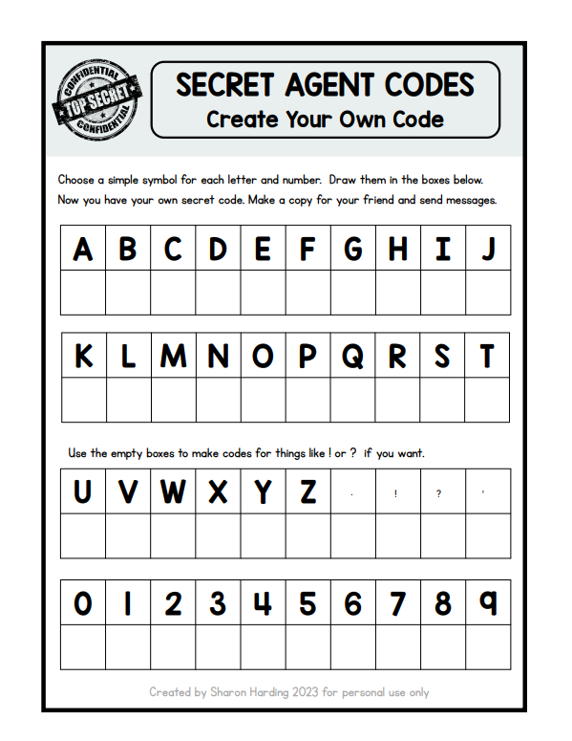
Children Choose a simple symbol for each letter and number.

Activity Three – Pig Pen Cipher
(suggested time for full activity 5 – 10 minutes)
The Pigpen Cipher is another example of a substitution cipher, but rather than replacing each letter with another letter, the letters are replaced by symbols.
Can the children work out how the Pigpen Cipher works? Allow the children some time to talk to partners and discuss any ideas as a class.
Children could have a go at creating their own Pigpen Cipher for a partner to decipher.
Extra questions to challenge students:
Compare the two ciphers so far. Which do you think is best? Which is easier to follow? Can you create your own Pigpen Cipher?
Ideas to support discussion in this task:
The cipher has an interesting history: although its true origins are unknown, it has been used by many groups. Most notoriously, it was the cipher of choice for use by the Freemasons, a secret society in the 18th Century. In fact, they used it so much, that it is often referred to as the Freemasons Cipher. However, it was not exclusively used by them, with Union prisoners in Confederate camps using it to communicate in the American Civil War.
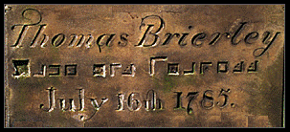
The Pigpen Cipher was used by the Freemasons in many aspects of their lives, and one of the most common still seen today is on gravestones. Below is an image of a gravestone which clearly contains the use of the Pigpen Cipher.
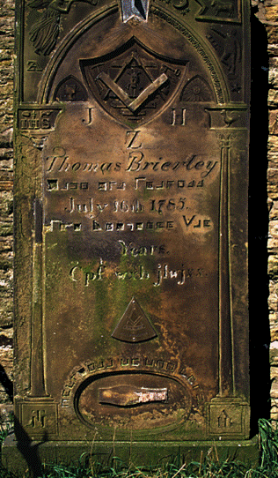

Activity Four – Make your own Code Breaker
(suggested time for full activity 15 – 20 minutes)
Follow the online instructions to create your own code breaker.
Link - https://www.crayola.ca/crafts/code-maker--breaker-craft

Activity Five – Book Cipher
(suggested time for full activity 15 –20 minutes)
Follow the online instructions to create your own book cipher. (Old books would need to be sourced as they need to be written in)
Link to video - https://www.youtube.com/watch?v=dVkUhArtT-w

Activity Six - Can You Read This?
(suggested time for full activity 5 minutes)
Allow the children some time to talk to partners and discuss any ideas as a class. Can the children read this?
I couldn’t believe that I could actually understand what I was reading. Using the incredible power of the human mind, according to research at Cambridge University, it doesn’t matter what order the letters in a word are, the only important thing is that the first and last letter are in the right place. The rest can be a total mess and you can still read it without a problem. This is because the human mind does not read every letter by itself, but the word as a whole. Amazing, huh? Yeah and I always thought spelling was important! See if your friends can read this too!
(suggested time for full activity 5 - 10 minutes)

Activity Seven – Learn how to Speak Pig Latin
(suggested time for full activity 5 - 10 minutes)
Pig Latin is a pseudo-language or argot where we use a formal technique altering English words. The basic rule is to switch the first consonant or consonant cluster to the end of the term and then adding suffix “ay” to form a new word. For instance, the word ‘pig’ would become igp+ay which becomes igpay.
Link to video - https://www.gonoodle.com/videos/92knjX/how-to-speak-pig-latin
https://bunnystudio.com/blog/a-quick-guide-for-translating-to-pig-latin-with-examples/
Link to Video explanation - https://youtu.be/-d8sBECOabY
https://youtu.be/-d8sBECOabY
Plenary
Which did the children like the most? Found the easiest to learn? The hardest? Most interesting? Can the children explain their code to their peers?

